Session 4:
Practical exercise

General Instructions for all groups

- A 29 year old female patient presented to the KT Motubatse clinic for with a one week history of nausea, vomiting and generalised body weakness.
- She also reported that she took medication for cough 3 weeks ago but she is still coughing. No fever
- On completion of assessment and examination you suspect that she could be pregnant and you also want to test for TB

In your group
- Break up the participants into six groups. Each group much use the case study to answer the questions and undertake an activity (where appropriate) for each section.
- Participants must refer to the PHC Laboratory Handbook for thus activity.
- For each group, print out the instructions for each group.
- Where possible, the facilitator can also provide some test tubes, a specimen bag and the N1 form with barcode labels for the applicable groups to use.
- At the end of the exercise, each group can come and present their answers and activities.
Groups to be formed
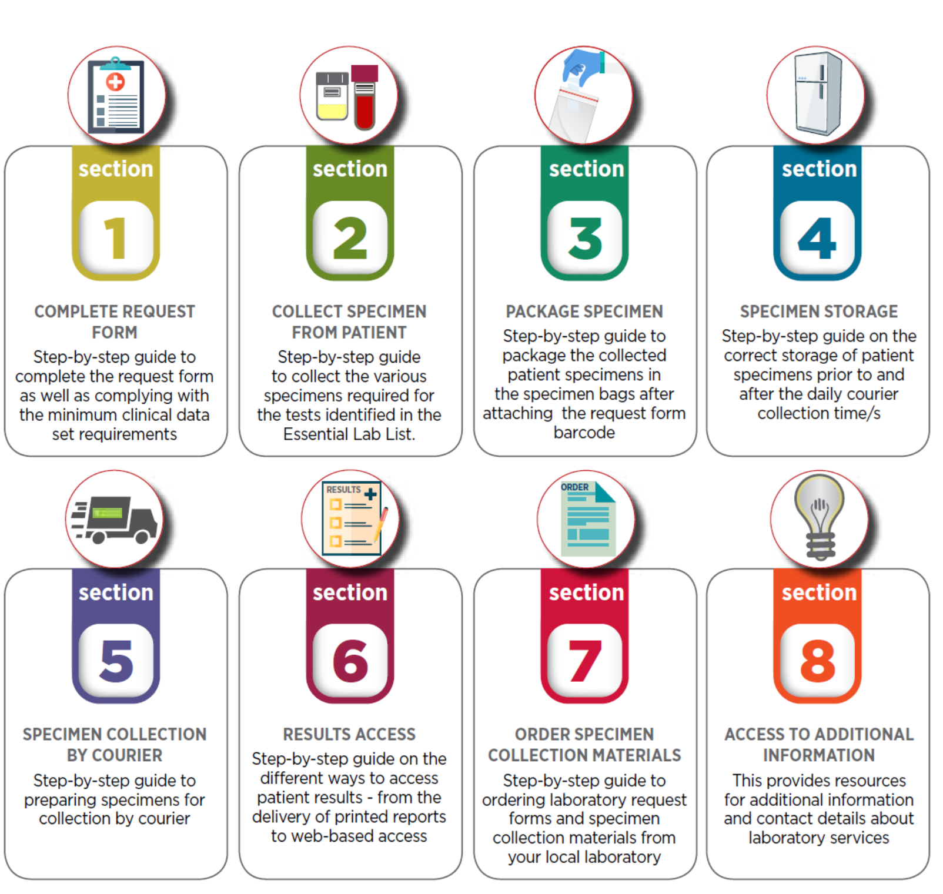

Group One: Section One (Complete Request Form)

What is the clinical assessment
What test/s need to be performed
Are the test/s listed in the PHC ELL
Which fields are mandatory when completing the request form
What impact will the test results have on further management of this patient?

Complete the N1 request form below:

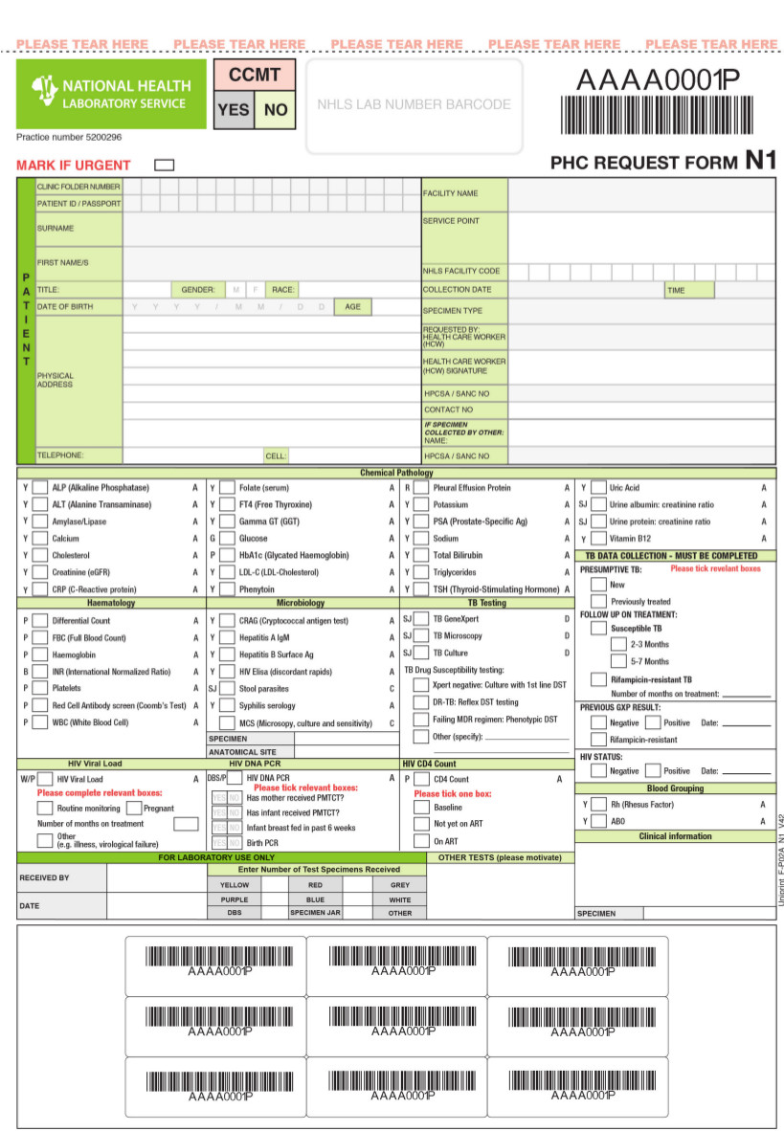

Group Two: Section Two (Collect Specimen)

Which specimens will you collect?
Identify the specimen collection materials required for the test?
What are the Infection Control Precautions (IPC) must be considered when collecting specimen?
What are the specimen handling requirements for the test/s?
Describe the specimen collection procedure/s for the test/s?

Group Three: Section Three (Package Specimen)

Describe how you would label the specimen/s?
Describe how you would attach the request form barcode labels?
What would you record in the patient file?
In which compartment would each specimen be placed?
Where would the request form be placed?
How many patient specimens can be placed in a specimen bag?

Group Four: Section Four (Specimen Storage)

Identify the specimen storage condition for the test/s required for this patient?
What would be the impact of dramatic temperature fluctuation of the test/s?
What information is required on the N4 Facility Specimen Register cover?
Describe what information you would capture for your patients in the N4 Facility Specimen Register?
Describe the designated area where you would drop of the package and recorded samples?

Group Five: Section Five (Specimen Collection by Courier)

How is the courier identified?
What are the courier arrangements for most health facilities?
What are the courier arrangements for most health facilities?
Describe how you would confirm that the samples awaiting courier collection match the entries in the N4 Facility Specimen Register cover?
Describe the procedure for recording samples handed over to the courier?

Group Six: Section Six (Manage Laboratory Results)

Describe the different mechanisms for receiving patient results?
How are the printed laboratory results delivered?
Describe what a log sheet is and what is required when the courier delivers patient results?
Describe the process for reviewing the delivered patient results?
Describe the process for reviewing the delivered patient results?
Describe how patients results are recorded and filed?

