GUIDELINE TO DEVELOP A SUB-DISTRICT/DISTRICT SPECIFIC

STANDARD OPERATING PROCEDURE

TO MANAGE COMPLAINTS, COMPLIMENTS AND SUGGESTIONS

This is a guideline to assist sub-district/districts to develop their own Standard Operating Procedure (SOP) to manage complaints, compliments and suggestions that is in line with the National Guideline to Manage Complaints, Compliments and Suggestions in the Public Health Sector of South Africa.
Sub districts/districts can use this document as a guideline to develop their own district specific SOP by amending or choosing from the options (highlighted in red) in the sections as indicated in the guideline.

April 2017

STANDARD OPERATING PROCEDURE (SOP)

TO MANAGE COMPLAINTS, COMPLIMENTS AND SUGGESTIONS

FOR

__________ SUB-DISTRICT/DISTRICT (fill in sub-district/district name)

Mr/Ms....................................... ................................
District Manager Date approved


Compiled by (author): ..............................
Date for next review: ........................

Table of Contents

1. Introduction 1
2. Procedure for lodging complaints 1
3. Acknowledging complaints 2
4. Recording and Investigating complaints 2
5. Resolving and Redress of complaints 4
6. Monitoring and Statistical data on complaints 5
7. Procedure for recording and management of compliments and suggestions 7

Table of Annexures
Annexure A: Complaint, compliment and suggestion form 8
Annexure B: Poster to lodge a complainant, give a compliment or make a suggestion 9
Annexure C: Complaints Register 10
Annexure D: Categories for complaints, compliments and suggestions 11
Annexure E: Complaints statistical data 13
Annexure F: Summary form on outcome of complaint investigation 14
Annexure G: Flow diagram of the SOP to manage complaints 15
Annexure H: Register for compliments 16
Annexure I: Register for suggestions 17
Annexure J: Statistical data on compliments 18
Annexure K: Statistical data on suggestions 19

Introduction
This standard operating procedure (SOP) describes the steps to follow when managing complaints, compliments and suggestions at the_______ (fill in name) sub-district/district office as well as the procedure to be followed by Primary Health Care (PHC) facilities in the district. Complaints, compliments and suggestions must be managed appropriately to ensure that problems are identified quickly and managed appropriately to the satisfaction of the patient/family or supporting person who lodged the complaint.

A complaint is defined as the dissatisfaction, displeasure, disapproval or discontent expressed verbally or in writing by any person about the specific health services being rendered and or care being provided within the health sector. The complaints procedure has not been designed to address the following:
- staff–specific grievances that is codified within Labour Relations legislation and thus be addressed through labour relations processes,
- complaints that relate more to broad national health policies, for example the placement and building of new health facilities, the drug regimens for the treatment of specific diseases or disapprovals expressed towards legislation falling under the Portfolio Responsibilities of the Minister of Health, e.g. the Choice on Termination of Pregnancy Act (Act 92 of 1996) and the Tobacco Products Control Amendment Act (Bill 14 of 2015) and
- complaints that relate to corruption which should be referred to the National Anti- Corruption Hotline (NACH).

A compliment is any expression of praise, commendation or admiration given by any person on health services being rendered and or care being provided within the health sector.

A suggestion is any proposal made or an idea that has been put forth by any person to improve the health services being rendered and or care being provided within the health sector.

Procedure for lodging complaints
- At the sub-district/district office complaints, compliments and suggestions will be managed by the _________ (fill in designation of staff member).
- The Facility Manager/ Complaints/Help Desk Officer is assigned the responsibility to receive/manage complaints in facilities (select the appropriate person for the facility)
- The public can lodge their complaints :
  - Verbally by calling or speaking to the person responsible for dealing with complaints that will complete a complaint, compliment or suggestion form on behalf of the patient/family or supporting persons that wants to lodge a complaint, see Annexure A. This official must always be available to assist vulnerable groups such as illiterate and disabled persons by listening to their complaints and writing it down on the official complaint, compliment or suggestion form. If the patient or their family/ supporting person do not speak the local language, an interpreter must be sought to assist the patient/family or supporting persons to lodge a complaint.
  - In writing by:
- Filling in the complaint, compliment or suggestion form and giving it to the staff member responsible for managing complaints, compliments and suggestions or placing it in the complaint, compliment and suggestion box. At the district office the box/boxes (choose applicable) are situated at......................... (insert the area/s). At facilities the box/boxes (choose applicable) are situated at entrances/exits of the facility. (add if there are additional areas).
- E-mailing the complaint
- Faxing the complaint
- Posting the complaint
- The poster to inform patients on how to lodge a complaint must be displayed at the entrances/exits of the district office and facilities. The poster must be placed next to all complaint, compliment and suggestion boxes and it must be available in at least two local languages. See Annexure B.
- To ensure children’s participation in the complaints process the parents/guardians of the children must be informed that they must request their children to report any complaints to their parents/guardians. Once a child has reported a complaint the parents/guardians must then follow the complaints procedure as set out above and lodge the complaint on behalf of the child.
- To ensure that patients who are disabled, elderly or mentally ill participate in the complaints procedure the person escorting the patient must be requested to report any complaints to their escort. Once the patients has reported a complaint the escort must then follow the complaints procedure as set out above and lodge the complaint on behalf of the patient.

Acknowledging complaints
- The staff member responsible for managing complaints must acknowledge complaints in writing or telephonically (date and time must be recorded on the complaints form) within 5 working days after receipt of a complaint in cases where the complaint was not handed directly to the responsible staff member.
- When a complaint is acknowledged, the patient/family or supporting persons must be informed of
  - The reference number allocated to the complaint.
  - The estimated time it will take to resolve the complaint.

Recording and Investigating complaints
- Opening of complaint, compliment and suggestion boxes
    - Complaint boxes must be opened daily (change if frequency is different) by the staff member responsible for managing complaints. Where feasible, at facilities, a member of the Clinic Committee should be present when the boxes are opened. If boxes are not opened daily, a notice of the schedule for opening of boxes must be displayed on to or next to the box.

- Recording of complaints
- All complaints received must be read and the details thereof recorded in the Complaints Register, see Annexure C or captured on the web-based/stand alone software for managing complaints (choose one applicable to your facility). A completed register for each month must be printed and filed in the complaints file at the end of each month.

c) Action to be taken according to priority
  - The complaint must be assessed immediately upon receipt to identify the severity/risk and the appropriate course of action that needs to be taken.
  - A risk rating of high and medium will be used. Complaints that fall within the criteria set for Patient Safety Incidents will be risk rated as high and all other complaints will be risk rated as medium.
  - Priority will be given to resolving issues that have a high risk and which must be escalated in facilities to the facility manager with immediate effect. The facility manager must escalate complaints that are identified as Severity Access Code (SAC) 1 patient safety incidents to the district office within 24 hours district office. The district office will escalate these complaints as well as other SAC 1 rated complaints that were directly lodge at the district office to the provincial office immediately to adhere to the 24 hours time-line.

- Investigation plan
- Each complaint must be investigated. All allegation(s) contained in a complaint must be written down to ensure that all aspects are investigated. It determines the specific issue(s) to be investigated as well as the facts that needs to be obtained to determine the outcome.
- A short plan on how to go about to investigate the complaint must be recorded. The plan should include:
  - who will be responsible to investigate each allegation,
  - who should be interviewed,
  - what records should be reviewed,
  - what questions should be asked.

- Identify system failures
  - Each complaint will be categorised according to the categories set out in Annexure D to assist the facility to identify the most commonly occurring system failures.
  - Facilities must complete Annexure E at the end of every month and submit it to the sub-district/district office that will submit a collated report to the provincial office or the report on categories must be generated from the web-based software for managing complaints, compliments and suggestions and filed. (choose one applicable for facilities).
  - The data on Annexure E will be used to identify significant system failures. The identified system failures will be analysed to determine the root cause by making use of one of the quality improvement tools as set out in the National Quality Improvement Guideline, page 17. Once problems and gaps have been identified, a Quality Improvement Plan must be developed and implemented.

Resolving and Redress of complaints
- The complaint will be resolved and the final outcome of the investigation conveyed to the patient/family or supporting person who lodged the complaint within a target time frame of 25 working days from the date the complaint was received.
- If the complexity of the investigation requires an extension of the 25 days period, the patient/family or supporting persons who lodged the complaint will be provided with a progress report within 25 working days and an estimated date for final response.
- The patient/family or supporting person who lodged the complaint will be given redress by:
  - Inviting the patient/family or supporting person who lodged the complaint to a redress meeting. A letter/ report/minutes of the meeting will be provided to the complainant.
  - Provide the patient/family or supporting person who lodged the complaint with a written letter via e-mail, post or fax.
- Redress should include the following:
  - An apology, explanation and acknowledgement of responsibility
  - Remedial action, which may include review or changing a decision on the service given to an individual; revising published material; revising procedures to prevent the same thing happening again; training or supervising staff; or any combination of these
- A complaint will be viewed as resolved under the following circumstances:
  - Patient satisfied/Redress done: The patient/family or supporting person who lodged the complaint indicates that he/she accepts the facility’s response regarding the complaint. When a complaint cannot be resolved to the satisfaction of the patient/family or supporting person who lodged the complaint, his/her reasons will be carefully documented as well as the attempts that were made to resolve the complaint. The complaints will be escalated to the district office for further management if needed.
  - Litigation: A patient/family or supporting person who lodged the complaint indicates during a redress attempt by the facility that he/she is not satisfied with the resolution and is going to take legal action against the facility.
  - Patient Safety Incident: It becomes apparent during the investigation that the complaint concerns a patient safety incident which will then be further managed through the patient safety incident management process. Where a complaint is identified as a patient safety incident, the reference number assigned to it in the Patient Safety Incident Register must be recorded in the Complaints Register.
  - Patient/family or supporting person who lodged the complaint cannot be traced: If additional information is required in order to investigate the complaint or to give redress, and the patient/family or supporting person was contacted once a week for three consecutive weeks without success, the complaint will be seen as resolved. The dates and the methods used to contact the patient/family or supporting persons must be documented as such.
- The form to log the processing of the complaint (Annexure F) must be completed or the data must be captured on the web-based software for managing complaints, compliments and suggestions (choose one applicable for the facility) once the investigation and redress has been finalised in order to have a summary on the management of the complaint.

Monitoring and Statistical data on complaints
- The forum for reviewing complaints, compliments and suggestions at the sub-district/district will consist of the following members: (Also indicate who the chairperson will be).
- Sub-district/district quality assurance manager (Chairperson, change if different)
- Sub-district/district manager
- staff responsible for coordinating complaints, compliment and suggestion management
- representative of the Labour Relations division (on ad hoc basis)
- managers of programmes
- district clinical specialist team member

- The terms of reference (TOR) for the forum at the sub-district/district will be to:
- Develop a SOP to manage complaints, compliments and suggestions, see section 8, for the facilities within their district that is in line with the National Guideline.
- Monitor that facility’s adherence to the sub-district/district’s SOP for managing complaints, compliments and suggestions.
- Monitor that complaint investigations are conducted and redress provided within 25 working days.
- Provide training to staff that is responsible for the management of complaints, compliments and suggestions.
- Investigate all complaints referred to or lodged with the sub-district/district office.
- Conduct at least quarterly meetings of which the minutes should be recorded. Ad hoc meetings can be scheduled as needed.(change if frequency differs)
- Compile and analyse sub-district/district statistical reports to identify trends.
- Implement system-wide sub-district/district initiatives to in future prevent similar negative trends as identified in statistical reports.
- Submit quarterly statistical reports to the provincial office or capture data on the web-based application from where provincial office will obtain the data (select the appropriate system that is used)
- Ensure that the knowledge obtained through the statistical analysis of complaints, compliments and suggestions inform existing as well as future guidelines and SOPs.

- The forum for reviewing complaints, compliments and suggestions in PHC facilities will consist of the following members: (Also indicate who the chairperson will be).
  - The Facility Manager (Chairperson, change if different)
  - Complaints/ Helpdesk Officer/ Public Relations Officer
  - One other staff member from any category
  - One community member serving on the Clinic Committee (change to apply to the facility’s setup)

- The terms of reference (TOR) for the forum in PHC facilities will be to:
- The facility’s committee responsible for complaint, compliment and suggestion management will ensure adherence to the procedures as set out in the sub-district/district office’s SOP to manage complaints, compliments and suggestions.
- Every facility’s committee will identify a designated complaints, compliment and suggestion staff member for their facility.
- Monitor the facility’s adherence to the SOP for the management of complaints, compliments and suggestions.
- Ensure the process whereby a complaint is lodged, a compliment is recorded or suggestion is made, is available in the facility in the form of posters or pamphlets in the official language(s) commonly understood by the communities that are served by the facility and the procedure is explained to all first time users.
- Ensure the facility has visible signposting to lead the patient or their families/supporting persons to the point where complaints should physically be lodged or compliments and suggestions be recorded.
- Monitor that complaint investigations are conducted and redress provided within 25 working days.
- Conduct monthly meetings of which the minutes should be recorded.
- Compile and analyse statistical reports to identify trends.
- Submit quarterly statistical reports to the district office or capture data on the web-based application from where district/provincial office will obtain the data (select the appropriate system that is used).
- Make recommendations to prevent similar future trends as identified in statistical reports.
- Disseminate lessons learned.
- Ensure that regular training of staff on the management of complaints, compliments and suggestions takes place.
- The sub-ditrict/district forum will meet monthly and the facility’s forum will meet every week. (change if frequency differs)
- All documents relating to each complaint (including original complaint letter and other correspondence) will be filed in the Complaints file together with a summary of the complaint (as captured on annexure A and F or as generated from the web-based software for managing complaints, compliments and suggestions) on top of the documentation (choose one applicable).
- Statistical data on complaints, compliments and suggestions will be recorded every month in the format as set out in Annexures E, J and K and submitted to the district/provincial office or the reports must be generated from the web-based software for managing complaints, compliments and suggestions. (choose one applicable). The statistical data will be presented at the forum for reviewing complaints, compliments and suggestions for discussion on a monthly basis.
- The complaint register as set out in section 4b must be filed together with the monthly statistical complaints’ forms.
- See annexure G contains a flow diagram that explains the SOP for managing complaints as set out in sections 1 to 6

- Procedure for recording and management of compliments and suggestions
- The public can record a compliment or make a suggestion:
  - Verbally by calling or speaking to the person responsible for dealing with complaint, compliments and suggestions. This official will complete a complaint, compliment or suggestion form on behalf of the patient/family or supporting persons, see Annexure A.
  - In writing by:
- Filling in the complaint, compliments, suggestion form and giving it to the Complaint/Help Desk Officer or placing it in the Complaint, Compliment and Suggestion Box. The boxes are situated at......................... (name the service areas)
- E-mailing the complaint
- Faxing the complaint
- Posting the complaint
- The poster to inform the patient/family or supporting persons how to record a compliment or suggestion must be displayed at the entrances/exits of the facility. The poster must also be placed next to all complaint, compliment, and suggestion boxes in at least two local languages. See Annexure B.
- All compliments and suggestions must be categorised, see Annexure D.
- All compliments and suggestions must be recorded in the register for compliments (Annexure H) and suggestions (Annexure I).
- Appropriate action taken on all compliments and suggestions must be recorded clearly in the applicable column in the registers.
- Monthly statistical data on compliments and suggested must be completed at the end of every month and submitted to the district/provincial office or the reports must be generated from the web-based software for managing complaints, compliments and suggestions. (choose one applicable). The statistical data will be kept and presented at the forum for reviewing complaints, compliments and suggestions for discussion on a monthly basis.

Annexure A: Complaint, compliment and suggestion form

FORM TO LODGE A COMPLAINT OR RECORD A COMPLIMENT OR SUGGESTION
Ref no | (office use)

Date completed

Do you want to: Complain Give a compliment Make a suggestion

Details of the person lodging a complaint or recording a compliment or suggestion
Surname
First Name
Contact details | Cell number
Contact details | Postal address
Contact details | Physical address
Contact details | E-mail address
Service area (e.g ward no, reception, pharmacy)
Hospital or clinic file number
If you are submitting on behalf of someone else, please complete the following:
Relation to the patient, e.g. mother, etc.
Patient’s Surname
Patient’s First Name
Contact details of the patient | Cell number
Contact details of the patient | Postal address
Contact details of the patient | Physical address
Contact details of the patient | E-mail address
Service area (e.g ward no, reception, pharmacy)
Patient’s hospital or clinic file number

Please describe the complaint or give a compliment or make a suggestion.
* Where possible also record the staff involved and department where the incident took place.
Date on which the incident took place:

_______________________________ ________________________________
Signature of person lodging the complaint Signature of patient

Annexure B: Poster to lodge a complainant, give a compliment or make a suggestion
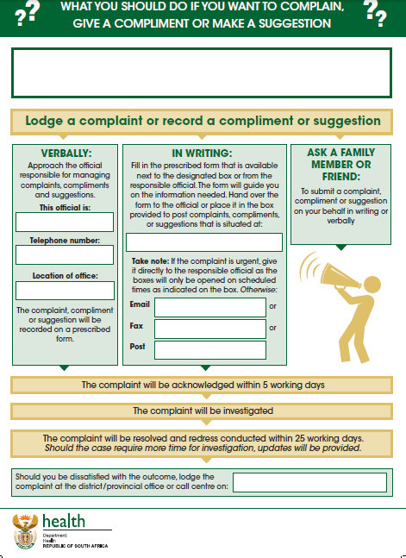
Annexure C: Complaints Register
Facility/district’s name: ______________________________________ Month/year: _____________________
Ref No.  (Column A) | Date Received | Patient/ family/ supporting person’s name and surname | Patient's name and surname | Service area where complaint was lodged | Summary description of the complaint | Information on  i.) Action taken, ii) Outcome, iii) Remedial action | Category of Complaint | Severity of Complaint (Risk Rating) | Type of Resolution | Date Resolved (Column B) | Number of working days to resolve Complaint (Column D)

Column name (e.g. A, B and D) in the heading of the complaints register refer to the columns to be completed in Annexure G:
- To obtain column A of Annexure G count the number of reference numbers for the month
- To obtain column B of Annexure G count the number of complaints resolved (count the rows where dates have been entered). Very important: also check previous month’s registers for complaints that have been resolved for the current month and add all the complaints that have been resolved for the current month. In some instances you can have more complaints resolved than received for a specific month because complaints of previous months were resolved in that specific month.
- To obtain column D of Annexure G count the number of complaints resolved within 25 days only. Same principle applies as previous bullet; therefore check previous month’s registers.

Annexure D: Categories for complaints, compliments and suggestions
Category | Description | Example of the type of complaints that could fall under the category | Example of the type of compliments that could fall under the category | Example of the type of suggestions that could fall under the category
Category | Complaints/compliments/ suggestions relating to;
- Staff attitude | The attitude and behaviour that staff display towards patients. | Staff that  - are rude towards  - don’t greet or show recognition of presence of the patient or families/support persons  - don’t respond to question or enquiry of  patients or their families/supporting persons | Staff that  - were friendly  - answered all questions | Improve the attitude of staff by:  - training on Batho Pele  - provide courses in courtesy
- Access to information | Patients having access and are provided with information upon request. | Patients not allowed access to their medical records, health information, referral pathways and services provided  Inability to get interpreter for people with speech impairment. | Staff that gave clear information on referral pathways and services provided. | Improve record management ensuring that records are locked at all times. Improve referrals by ensuring that referral pathways are made clear
- Physical access | Patients having access to services. | Facilities that closes before operating times, Patients being turned away without being consulted Patients not referred to higher level of care where indicated | Facilities that stay open even after closing times to ensure that all patients have been consulted | Improve processes within the facility to ensure that all patients have access by including additional shifts
- Waiting times | Triaging of patients to ensure that waiting times at service areas are managed efficiently. | Long waiting times in queues at service areas  Elderly and disabled persons not given priority treatment | Short waiting times in queues at service areas  Elderly and disables persons are given priority treatment | Reduce waiting times by instituting a booking procedure
- Waiting list | the effective management of waiting list for elective procedures. | Patients put on waiting list for a long period of time before receiving elective procedures as required or scheduled | Waiting list for elective procedures are kept short and on schedule | Shorten waiting lists for elective procedures by contracting in staff from the private sector
- Patient Care | Care and professional treatment provided by health care professional according to clinical protocols/guidelines. | Health care professionals not consulting/assessing patients on schedule as prescribed in treatment protocols  Misdiagnoses of patient’s condition  Not taking care of patient’s personal needs (bathing, feeding)  Elective procedures that resulted in unnecessary harm to patients | Health care professionals adhering to the prescribed protocols, referring patients for second opinions where indicated. Staff that went the extra mile to take care of patient’s personal needs | Improve patient’s care by appointing additional staff, train staff ect.
- Availability of medicines | The appropriate management of stock levels of medicines to prevent stock-outs. | Patients not issued with medication as medicines are out of stock or is expired  Not giving explanation and making alternative arrangements for non-available stock | All medicines available. Where medicines are out of stock alternative arrangements are made to ensure that patients do receive their medication | Improve medicine stock control by conducting weekly stock control to ensure that medicines are ordered in time
- Safe and secure environment | The provision of a safe and secure environment to patients. | Patients assaulted by other patients or visitors  Patients loosing personal possessions while being admitted  Slippery floor, non-availability of appropriate rails at ramps | Security measures are in place to ensure patient’s safety | Improve security levels by appointing additional security staff, train staff
- Hygiene and cleanliness | The provision of a hygienic and clean environment to patient. | Dirty and unhygienic service areas  None-availability of water, toilet papers or soap  Non-availability of linen and dirty linen | Clean service areas  Water, toilet paper and soap is always available | Suggestions to improve the cleanliness of service areas and to ensure that toilet paper are always available
- Other | Any other complaint that cannot be categorised under section 1 to 9.

Annexure E: Complaints statistical data
Facility/district’s name: _____________________ Financial year: ________________________
Column name | INDICATORS |  |  |  |  | CATEGORIES
Column name | A | B | C | D | E | F | G | H | I | J | K | L | M | N | O | P
Month: | # Complaints received | # Complaints resolved | % Complaints resolved (Column B÷A) | # Complaints resolved within 25 working days | % Complaints resolved within 25 working days (D÷B) | Staff attitude | Access to information | Physical access | Waiting times | Waiting list | Patient care | Availability of medicines | Safe and secure environment | Hygiene and cleanliness | Other | Total per month (Sum of Columns F to O)
April
May
June
Tot Q1
Jul
Aug
Sept
Tot Q2
Oct
Nov
Dec
Tot Q3
Jan
Feb
March
Tot Q4
TOTAL

AVG (Tot/12)
% for financial year (Total of Column F/G/H/I/J/K/L/M/N/O ÷ Total Column P)

Annexure F: Summary form on outcome of complaint investigation

Ref no

Manner in which complaint was lodged (mark with an “X”) | Written
Manner in which complaint was lodged (mark with an “X”) | Verbal
Manner in which complaint was lodged (mark with an “X”) | Physical visit

Date complaint lodged |  | Date of acknowledgement |  | Number of days to acknowledge complaint
Date complaint resolved |  | Number of working days to resolve complaint (date resolved – date lodged)

Information on i) Action taken, ii) outcome, iii) remedial action

Category of Complaint(mark with an “X”) | Staff attitude | Access to information |  |  | Physical access |  |  | Waiting times |  | Waiting list
Category of Complaint(mark with an “X”) | Patient care |  | Availability of medicines | Safe and secure environment |  |  | Hygiene and cleanliness |  | Other
Risk Rating(mark with an “X”) | Medium |  |  |  |  | High
Date of redress

Type Of Resolution (mark with an “X”) | Patient Satisfied/redress done
Type Of Resolution (mark with an “X”) | Patient Safety Incident
Type Of Resolution (mark with an “X”) | Litigation
Type Of Resolution (mark with an “X”) | Patient/family/supporting person couldn’t be traced

Annexure G: Flow diagram of the SOP to manage complaints
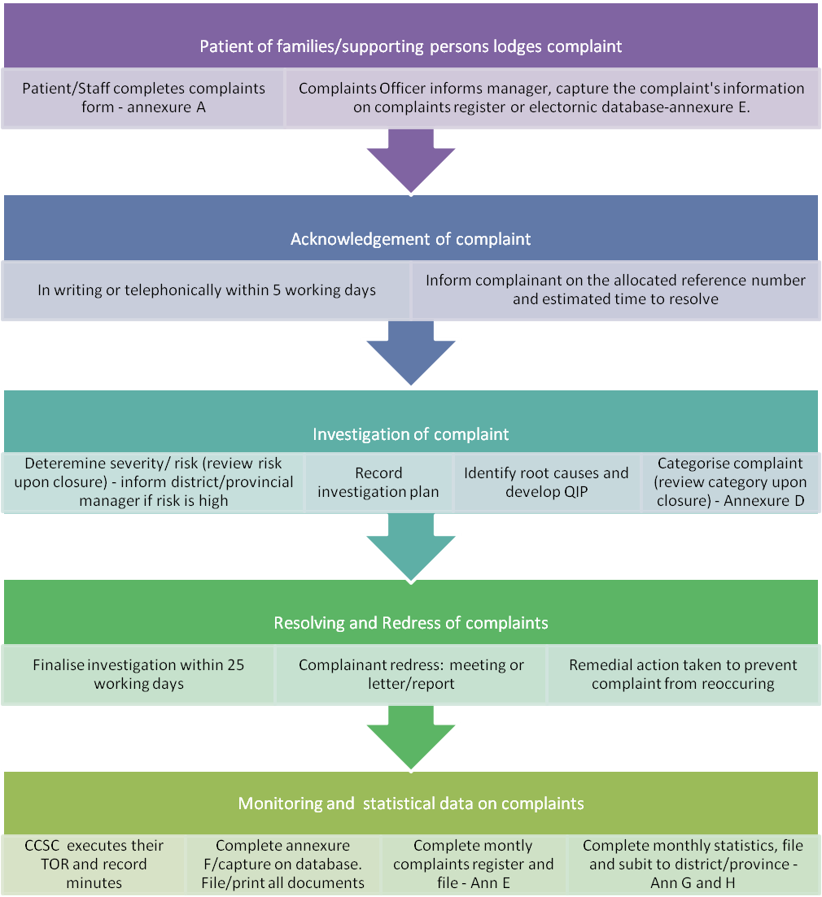

Annexure H: Register for compliments
Facility/district’s name: _______________________ Month and year: ______________
Ref No. | Date Received | Name & surname of person who recorded the compliment | Patient's Name & Surname | Service area where compliment originated from | Summary description of the compliment | Information on  action taken | Category

Annexure I: Register for suggestions
Facility/district’s name: _______________________ Month and year: ______________
Ref No. | Date Received | Name & surname of person who recorded the suggestion | Patient's Name & Surname | Service area where suggestion originated from | Summary description of the suggestion | Information on  action taken | Category

Annexure J: Statistical data on compliments

Facility/district’s name: _______________________ Financial year: ______________
Column name | INDICATOR | CATEGORIES
Column name | A | B | C | D | E | F | G | H | I | J | K | L
Month: | # Compliment received | Staff attitude | Access to information | Physical access | Waiting times | Waiting list | Patient care | Availability of medicines | Safe and secure environment | Hygiene and cleanliness | Other | Total per month (Sum of Columns B to K)
April
May
June
Tot Q1
Jul
Aug
Sept
Tot Q2
Oct
Nov
Dec
Tot Q3
Jan
Feb
March
Tot Q4
TOTAL

AVG (Tot/12)
% for financial year (Total of Column B/C/D/E/F/G/H/I/J/K÷Total Column L)

Annexure K: Statistical data on suggestions
Facility/district’s name: _______________________ Financial year: ______________
Column name | INDICATOR | CATEGORIES
Column name | A | B | C | D | E | F | G | H | I | J | K | L
Month: | # Suggestions received | Staff attitude | Access to information | Physical access | Waiting times | Waiting list | Patient care | Availability of medicines | Safe and secure environment | Hygiene and cleanliness | Other | Total per month (Sum of Columns B to K)
April
May
June
Tot Q1
Jul
Aug
Sept
Tot Q2
Oct
Nov
Dec
Tot Q3
Jan
Feb
March
Tot Q4
TOTAL

AVG (Tot/12)
% for financial year (Total of Column B/C/D/E/F/G/H/I/J/K ÷ Total Column L)

