Draft National Guideline for Management
of Patient Waiting Times
at Health Facilities
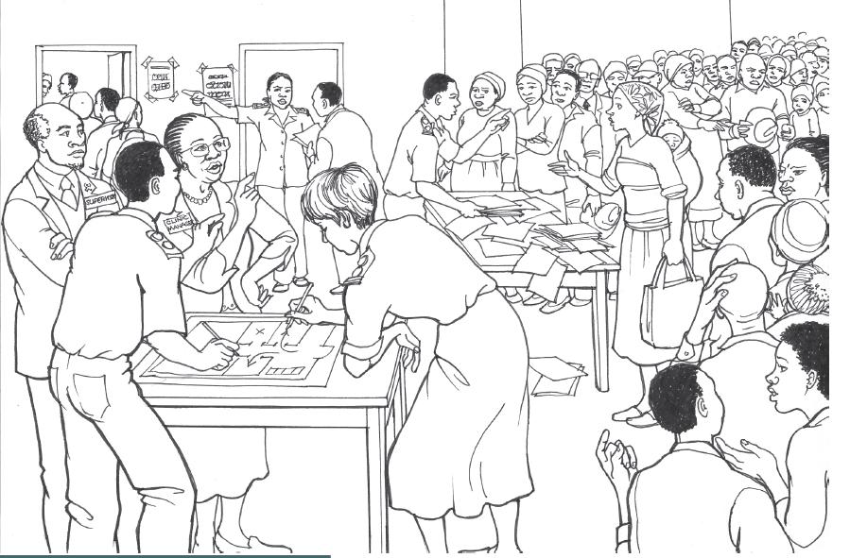




Acknowledgements

Patient waiting times in health facilities are internationally recognised as a key indicator of the functional status of health system. It is a very tangible factor that impacts on patient’s perception and experience of care.
Long patient waiting times are common in health facilities in South Africa and have clearly been identified as a key health system challenge. Patient waiting time is therefore included in the six Ministerial priority areas for patient-centred care in striving towards the goal to achieve Universal Health Care and implement National Health Insurance.
The purpose of this guideline is to provide managers in the health system with a standardised methodology to measure and analyse patient waiting times and to use the analyses to identify specific challenges that require interventions to improve the waiting time spent by patients at health facilities. This guideline further provides recommendations for interventions to alleviate long patient waiting times. We trust that this guideline will be beneficial to health care providers and users of the health system in delivering services that meet the Norms and standards regulations applicable to different categories of health establishments.

Ms Jeanette Hunter (DDG: Primary Health care and Hospital systems) led the development and completion of this guideline. Ms Annie Jautse developend the first draft. The final document has been compiled with technical support from Ms Annie Jautse, Dr Shaidah Asmall, Dr Ozayr Mahommed and Ms Ronel Steinhöbel.
I sincerely thank the national Department of Health managers and provincial department of health managers who provided insightful comments and direction to the final guideline.

MS MP MATSOSO
DIRECOTR-GENERAL: HEALTH
DATE:
TABLE OF CONTENT
1. INTRODUCTION 4
2. FRAMEWORK FOR THIS GUIDELINE 5
2.1 Purpose 5
2.2 Legislative and Regulatory mandates 5
2.3 Structure of the framework related to service delivery platform 6
3. MEASUREMENT OF PATIENT WAITING TIMES 7
3.1 Measurement of patient waiting times in Primary Health Care facilities 7
3.1.1 Methodology 7
3.1.2 Analysis and Results 10
3.1.3 Interventions 12
3.1.4 Compile a Quality Improvement plan 12
3.2 Measurement of patient waiting times in Hospitals 13
3.2.1 Methodology 13
3.2.2 Analysis and Results 16
3.2.3 Interventions 18
3.2.4 Compile a Quality Improvement plan 18
4. RECOMMENDED INTERVENTIONS TO ALLEVIATE LONG WAITING TIMES 19
4.1 Patient record management 19
4.2 Facility navigation 20
4.4 Clinical services organisation 20
4.5 Referrals 21
4.6 Communication 21
4.7 Human Resource management 21
5. REFERENCES ...................................................................................................................... 22

LIST OF FIGURES
Figure 1: Service across different levels within the Health Service Delivery Platform 6
Figure 2: PWT Monitoring Tool for PHC facilities: 8 hour service and MOU 9
Figure 3: PWT Monitoring Tool for PHC facilities: Emergency Unit 9
Figure 4: PWT Monitoring Tool for hospitals: Admissions 14
Figure 5: PWT Monitoring Tool for hospitals: Emergency unit 14
Figure 6: PWT Monitoring Tool for hospitals: OPD 15

LIST OF TABLES
Table 1: Sample size estimates for patient waiting time survey 8
Table 2: Format to summarise patient waiting time survey results for PHC facilities 11
Table 3: Format to summarise patient waiting time survey results for hospitals 17

LIST OF APPENDICES
Appendix A: Patient Waiting Time Monitoring Tool for PHC facilities: 8 hour service area 23
Appendix B: Patient Waiting Time Monitoring Tool for CHC: 24 Hour Emergency Unit 24
Appendix C: Patient Waiting Time Calculation Tool: PHC facilities 25
Appendix D: Patient Waiting Time Monitoring Tool for hospitals: Admissions Unit 26
Appendix E: Patient Waiting Time Monitoring Tool for hospitals: Emergency Unit 27
Appendix F: Patient Waiting Time Monitoring Tool for hospitals: OPD 28
Appendix G: Patient Waiting Time Calculation Tool: Hospitals 29

- INTRODUCTION

South Africa has a vision of Health for All as expressed in the National Development Plan 2030. This vision includes the provision of health services to patients in a dignified manner. Thus, management of patient waiting times (PWT) is important as a key contributory factor to patient’s perception of the experience of care provided by health system.¹ PWT is a reflection of the responsiveness of the health system to the needs and demands for these services especially as South Africa strives towards the provision of Universal Health Care through the intro introduction of the National Health Insurance as a vehicle to achieve this.

PWT is defined as the time interval for which one has to wait after placing a request for an action or a service and before the action or service actually occurs. In terms of health services, this would relate to time spent receiving services including health promotion and prevention messaging, clinical consultations and the receiving of treatment. Total time spent in a facility is disaggregated into PWT and clinical service time; this ratio is a good indicator of clinical efficiency.

Long PWT are common in health facilities in South Africa and has clearly been identified as a key health system challenge.² PWT is therefore included in the six Ministerial priority areas for patient-centred care. According to the National Health Care Facilities Baseline Audit conducted in 2012, the average score for the country for PWT was 68%. Hospitals fared better, obtaining an average of 84% while Primary Health Care (PHC) facilities obtained an average of 66%.There were significant differences in the percentage scores obtained per province for PWT which ranged from 40% to 69%.³ Scores obtained for the 2017/18 financial year on the Ideal Clinic Framework for the sub-component Patient Waiting Time was 73%.⁴

The measurement and regular reporting of PWT highlights the bottle-necks or delays, enables monitoring of the effectiveness of the health system’s performance and assists in designing interventions to overcome these challenges.

This guideline sets out the methodology for measurement and analysis of PWT in facilities. A web-based information system for PWT has been developed on the Ideal Health Facility website to provide the analysis and results of PWT surveys. This will assist in determining the bottle-necks within each facility and/or unit and in developing an appropriate intervention to improve PWT.

(Proposed process to be followed for consultation): The first draft guideline was developed and circulated to provincial heads of health with a request to provide inputs. Presentations were made at the Management Committee of the National Department of Health as well as the National Health Information Systems for South Africa Committee during. Inputs received on consultations were considered and relevant edits were done to develop the final guideline.

- FRAMEWORK FOR THIS GUIDELINE

  - Purpose

The purpose of this guideline is to provide managers in the health system with:
- the methodology to measure PWT,
- methods to analyse the results of the PWT survey,
- interventions to alleviate long PWT.

  - Legislative and Regulatory mandates

This guideline is underpinned by key South African Legislative and Regulatory mandates and is aligned to key strategies and efforts to achieve improved health. These include the following:
- South African Constitution, 1996 (Act 108 of 1996): Section 27 of the Bill of Rights states that everyone has the right to have access to health care services. The state must take reasonable legislative and other measures, within its available resources, to achieve the progressive realisation of this right.
- National Health Act, 2003 (Act 61 of 2003): The Act stipulates that a national health system must provide in an equitable manner the population of the Republic with the best possible health services that available resources can afford.
- Norms and standards regulations applicable to different categories of health establishments, February 2018: These regulations were published in accordance with Section 78 of the National Health Act. Section 22 of the Regulations sets the standards for monitoring PWT.

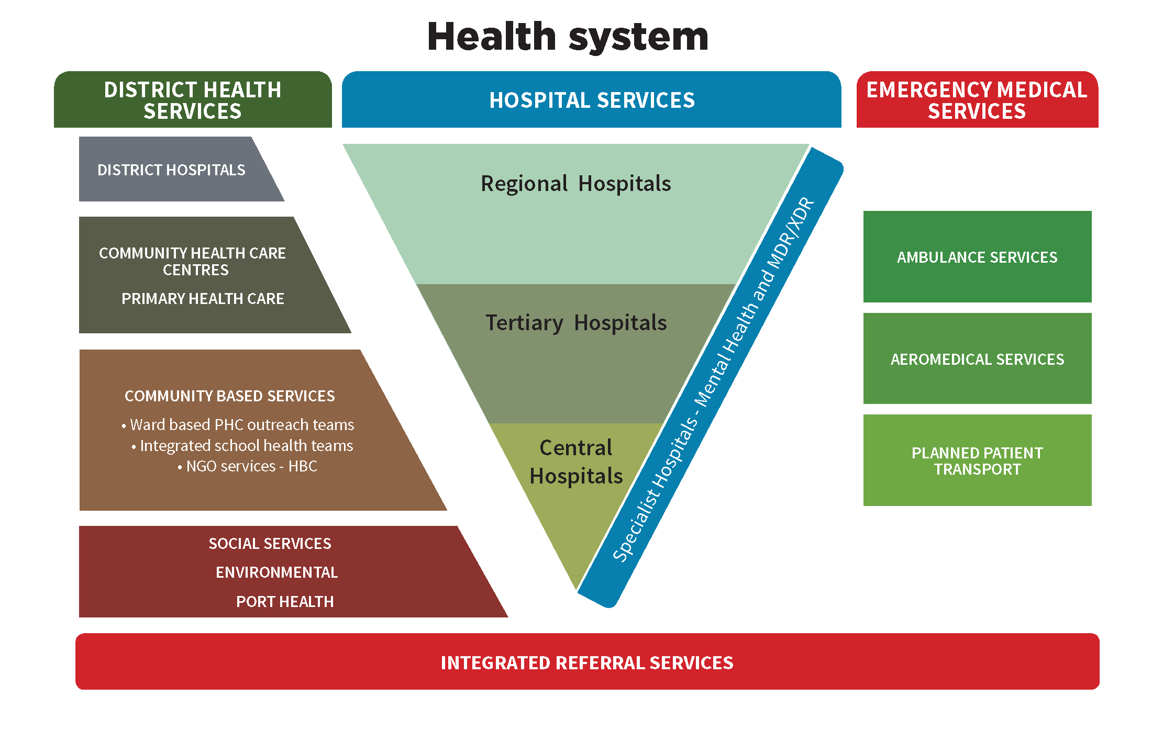
2.3 Structure of the framework in relation to service delivery platform
Figure 1: Service across different levels within the Health Service Delivery Platform

The structure depicted in Figure 1 of services delivered within the health system clearly reflects district health service and hospital services as the key components of the service delivery platform. District health services consist of primary health care (PHC) facilities and district hospitals. PHC facilities consist of PHC clinics and Community Health Care centres (CHCs). Hospital services include the various levels of hospitals as differentiated by the services that they render. This framework provides guidance for the measurement and management of PWT across the components of the health service delivery platform, i.e. PHC facilities and hospitals.

The measurement methodology and analyses of results are different for PHC facilities and hospitals and will therefore be discussed in separate sections.

- MEASUREMENT OF PATIENT WAITING TIMES

Each facility must develop a standard operating procedure for the Management of PWT that is aligned to this guideline and should outline the following:
- time frames to conducts PWT surveys,
- units where the survey will be conducted (applicable for hospitals),
- numbers of patients to be surveyed in the facility/every unit in the hospital
- PWT monitoring tools to be used,
- method to analyse PWT surveys, and
- designate staff members in specific roles that will be responsible to oversee and conduct the PWT survey.
The methodology outlined in sections 3.1 and 3.2 below is recommended for facilities that do not have an electronic PWT management system. Facilities that have an electronic PWT management system must verify that the system will provide the necessary information as required in this guideline.

  - Measurement of patient waiting times in Primary Health Care facilities

    - Methodology
Step 1: Schedule a day in quarter 2 and quarter 4 of every financial year to conduct the PWT survey.
Step 2: Determine the sample size of patients to be surveyed. To ensure that the sample size lay within the 95% Confidence Interval, use the World Health’s Organizations’ sample size determination in health studies practical manual to determine the sample size.⁵ See Table 1. For CHC’s, the PWT survey must be conducted at the 8 hour service area, the Emergency Unit and the Midwife Obstetric Unit (MOU), thus the headcount per day of each area/unit is used to determine the sample size for each area/unit separately.

Average head count per day | Sample size | Average head count per day | Sample size
10 | 10 | 700 | 248
20 | 19 | 800 | 260
30 | 28 | 1000 | 278
50 | 44 | 1200 | 291
75 | 63 | 1500 | 306
100 | 80 | 2000 | 322
150 | 108 | 2500 | 333
200 | 132 | 3500 | 346
250 | 152 | 5000 | 357
300 | 169 | 7500 | 365
400 | 196 | 10000 | 370
500 | 217 | > 10000 | 384
600 | 234
Table 1: Sample size estimates for patient waiting time survey

Step 3: Make copies of the PWT Monitoring Tool, Appendix A (8 hour service and MOU) and Appendix B (Emergency unit), according to the number of patients to be surveyed as determined in Step 2. Complete the name of the facility, the date of the PTW survey and the number of the survey on every form. See Figure 2 and 3. The red circles indicate areas that need to be completed by the facility.
Step 4: On the day of the survey use systematic sampling to select the patients according to the sample size that was determined in Step 2. For example if the daily headcount of the area/unit is 400, divide the daily headcount by the sample size (according to Table 1), i.e. 400 ÷ 196 = 2.04. The first patient will be selected randomly; thereafter every 2nd patient will be selected for the survey if the sample size is 196.
Step 5: The queue marshal (or designated staff member) must hand a copy of the PWT Monitoring Tool to every patient with time of entry into facility recorded on this Tool, see Figure 2 and 3.

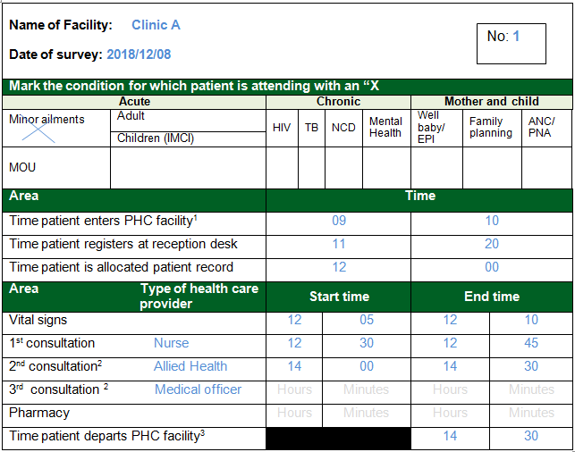
Figure 2: PWT Monitoring Tool for PHC facilities: 8 hour service and MOU

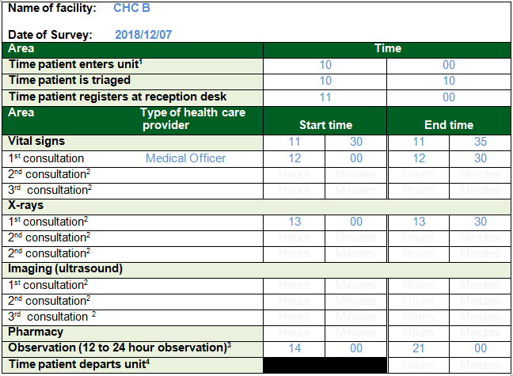
No: 1
Figure 3: PWT Monitoring Tool for PHC facilities: Emergency Unit
Step 6: Reception staff (or designated staff member) must place the PWT Monitoring Tool in the records of those patients that were selected to be surveyed.
Step 7: Each health care provider that interacts with the patient must record the time the patient enters and leaves the service point, i.e. if referred from medical officer or nurse to lay counsellor or allied health services (Rehab, social worker, nutritionist, etc). Also note down the type of health care provider that provided the service. See Figure 2 and 3.
Step 8: At the last service point, record the time the patient leaves the facility. Note: if patient is to return to facility for follow-up appointments then this time of departure should be recorded at reception when the patient makes their appointment. See Figure 2. If the patient was seen at the Emergency Unit and is kept for observation, the time the patient’s observation is completed is recorded. See Figure 3.
Step 9: At the end of the day, the completed PWT Monitoring Tool must be collected from the records and reconciled from each area/unit to ensure that all the surveys are available for analysis.
Step 10: All returns to be captured by the designated member using the PWT Module on the Ideal Health Facility web-based information system (www.idealhealthfacility.gov.za ).

    - Analysis and Results
Step 11: Analyse the PWT data using the PWT Calculation Tool, Appendix C. If the web-based information system is used, the times will be auto generated.
Step 12: Summarise the results using Table 2.

Name of Facility:  ___________________ | AVG Time / sample size  8 Hour service area |  |  | AVG Time / sample size  Emergency unit |  |  | AVG Time / sample size  MOU |  |  | AVG Time/ sample size for the Facility
Financial year: __________ | Q2 | Q4 | AVG Fin  Year | Q2 | Q4 | AVG Fin  Year | Q2 | Q4 | AVG Fin  Year | Q2 | Q4 | AVG Fin  Year
Description
- Sample size
- Average clinical service time
Vital signs
Acute stream
Mother and child stream
Chronic stream
Medical officer
Allied Health services
Pharmacy
Imaging
X-rays
Observation
- Average PWT
Registration
Patient record
Triage
Vital signs
Acute stream
Mother and child health stream
Chronic stream
Medical officer
Allied Health services
Pharmacy
Imaging
X-rays
Observation
- AVG Time spent
Table 2: Format to summarise patient waiting time survey results for PHC facilities

Step 13: Compare the PWT for each quarter with the previous quarter to establish trends and need for improvement.
Step 14: If the average time spent in the facility by patients exceeds three hours, establish which service areas are causing the bottle-neck by using the National Quality Improvement Guideline 2012 (www.idealhealthfacility.co.za).

    - Interventions
Step 15: Address identified deficiencies in bottle-neck areas. See section 4.

3.1.4 Compile a Quality Improvement plan

Step 16: The Quality Improvement Plan (QIP) should include the following
- Summary of PWT results, see Table 2.
- Update the existing facility QIP (see National Quality Improvement Guideline and use the Quality Improvement template).
- Ensure that the QIP highlights the following:
  - identified bottle necks
  - suggested interventions with time frames for implementation

  - Measurement of patient waiting times in Hospitals

The measurement of hospitals will be confined to:
- inpatient admission,
- outpatients department (OPD) and,
- Emergency Unit

    - Methodology
Step 1: Schedule a day in quarter 2 and quarter 4 of every financial year to conduct the PWT survey.
Step 2: Determine the sample size of patients to be surveyed. To ensure that the sample size lay within the 95% Confidence Interval, use the World Health’s Organizations’ sample size determination in health studies practical manual to determine the sample size. ⁵ See Table 1. For hospitals the PWT survey must be conducted at the inpatient admissions unit, the OPD and the Emergency Unit thus the headcount per day of each section/unit is used to determine the sample size for each section/unit separately. PWT in large hospitals with multiple OPD sections e.g. Medical, Surgical, ENT, Cardiology, Paediatrics must be determined for each OPD.
Step 3: Make copies of the PWT Monitoring Tool, Appendix D (Admissions Unit), Appendix E (OPD) and Appendix F (Emergency Unit) according to the number of patients to be surveyed as determined in Step 2. Complete the name of the facility the date of the PTW survey and the number of the survey on every form. See Figure 4, 5 and 6. The red circles indicate areas that need to be completed by the facility.
Step 4: On the day of the survey use systematic sampling to select the patients according to the sample size that was determined in Step 2. For example if the daily headcount of the area/unit is 400, divide the daily headcount by the sample size (according to Table 1), i.e. 400 ÷ 196 = 2.04. The first patient will be selected randomly; thereafter every 2nd patient will be selected for the survey if the sample size is 196.
Step 5: The queue marshal (or designated staff member) must hand a copy of the PWT Monitoring Tool to every patient with time of entry into the unit recorded on this Tool, see Figure 4, 5 and 6.
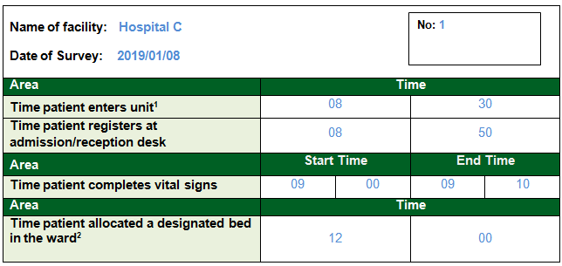
Figure 4: PWT Monitoring Tool for hospitals: Admissions

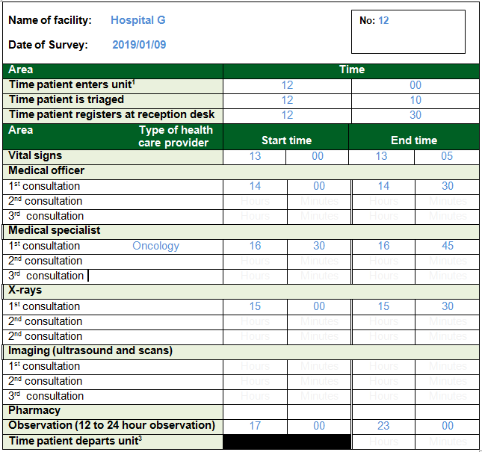
Figure 5: PWT Monitoring Tool for hospitals: Emergency unit
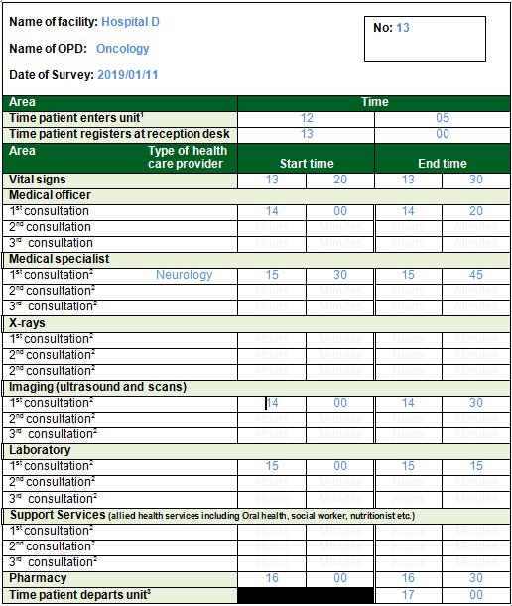
Figure 6: PWT Monitoring Tool for hospitals: OPD

Step 6: Reception staff (or designated staff member) must place the PWT Monitoring Tool in the records of those patients that were selected for the survey.
Step 7: Each health care provider that interacts with the patient must record the time the patient enters and leaves the service point, i.e. if referred from medical officer to medical specialist, allied health services (Rehab, social worker, nutritionist, etc), diagnostic services (radiology, imaging services, laboratory) and pharmacy. Every touch point must record start and end time of each interaction with the patient.
Step 8: Record the time at the last touch point as defined below.
- Admission: all administrative processes completed and patients allocated a designated bed in the ward. See Figure 4.
- OPD: the pharmacy is usually the exit touch point after patient has made their return appointment at the designated reception or administrative point. See Figure 5.
- Emergency unit: on discharge to go home or transfer from Emergency unit into inpatient ward or admission for observations within the Emergency unit. See Figure 6.

Step 9: At the end of the day, the completed PWT Monitoring Tool must be collected from the records by the designated staff member and reconciled to ensure that all copies are returned for analysis.

Step 10: All returns to be captured by the designated member using the PWT Module on the Ideal Health Facility web-based information system (www.idealhealthfacility.gov.za ).

    - Analysis and Results
Step 11: Analyse the PWT data using PWT Calculation Tool, Annexure B. If the web-based information system is used, the times will be auto generated.
Step 12: Summarise the results using Table 3

Name of Facility:  ___________________ | AVG Time / sample size  Admission |  |  | AVG Time / sample size Name of OPD:  ___________* |  |  | AVG Time / sample size  Emergency Unit |  |  | AVG Time / sample size  for the Facility
Financial year: __________ | Q2 | Q4 | AVG Fin  Year | Q2 | Q4 | AVG Fin  Year | Q2 | Q4 | AVG Fin  Year | Q2 | Q4 | AVG Fin  Year
DESCRIPTION
- Sample size
- Average clinical service time
Vital signs
Medical officer
Medical specialist
Allied Health services
Pharmacy
Imaging
X-rays
Laboratory
Observation
- Average PWT
Registration
Triage
Vital signs
Medical officer
Allied Health services
Pharmacy
Imaging
X-rays
Laboratory
Observation
Bed allocated
- AVG Time spent
* Note: Add the name of the OPD and additional columns for OPD according to the number of OPDs in the facility
Table 3: Format to summarise patient waiting time survey results for hospitals

Step 13: Compare the PWT for each quarter with the previous quarter to establish trends and need for improvement.
Step 14: If the average time spent in each of the identified service areas by patients exceeds three hours, establish what and where the bottle-necks are in each area by using the National Quality Improvement Guideline.

    - Interventions
Step 15: Address identified deficiencies in bottle-neck areas, see section 4.

3.2.4 Compile a Quality Improvement Plan
Step 16: The Quality Improvement Plan (QIP) should include the following
- Summary of PWT results, see Table 2.
- Update the existing facility QIP (see National Quality Improvement Guideline and use the Quality Improvement template).
- Ensure that the QIP highlights the following:
  - identified bottle necks
  - suggested interventions with time frames for implementation

- RECOMMENDED INTERVENTIONS TO ALLEVIATE LONG WAITING TIMES

The PWT survey analysis assists in identifying specific bottleneck areas which require intervention to ensure that the health facility functions optimally to deliver services within acceptable timeframes. Health systems analysis has over time identified certain factors that contribute to these long PWT and thus below suggested interventions that could assist a facility to improve their PWT.

  - Patient record management
To reduce PWT, records should be retrieved in the shortest possible time. The following principles should be instituted to ensure the quick retrieval of patient records:
- Single record storage room: Patient records should ideally be stored in a single record storage room that is in close proximity to the patient registration desk.
- Effective and efficient filing system refer to: The National Guideline for filing, archiving and disposal of patient records in PHC facilities to file, archive and dispose patient records that is in line with the National Archives and Records Service of South Africa Act, 1996 (Act 43 of 1996). The same principles can be applied for hospitals.
- Archiving and disposal of patient records refer to : The National Guideline for filing, archiving and disposal of patient records in PHC facilities provides guidelines for PHC facilities to file, archive and dispose patient records that is in line with the National Archives and Records Service of South Africa Act, 1996 (Act 43 of 1996). The same principles can be applied for hospitals.
- Pre-retrieval of patient records with booked appointments: Where applicable, appointments must be scheduled for patients. The records for patients with appointments must be pre-retrieved not later than a day before the patient’s appointment.
- Electronic patient record information management system: Assists with retrieval of patient records. The system also provides a back up to ensure that patient record is not lost.
- Electronic patient record: prevent loss of records and easy access.

  - Facility navigation
- Signage
Adequate and appropriate signage should be provided. This signage should be colour coded and provided in different local languages to ensure that the vast majority of the user of the service can find their way around the facility.
- Help Desk
Ensure consistent availability of a help desk official at the help desk to provide required information to users.
- Queue marshals
Queue marshals facilitate movement of patients in waiting areas.

  - Facility infrastructure design
The design of the facility should enhance the lean principles of patient flow to ensure patients can access services in a unidirectional manner thus saving time in moving from one service point to the next.

  - Clinical services organisation
- Integrated Clinical Service Management (ICSM): at PHC facilities the ICSM model should be instituted to ensure patients are managed based on the need for the various services.
- Patient appointment system: an appointment system that include both date and time allocations should be implemented to ensure all available human resources are adequately and efficiently utilised.
- Triage: In Emergency units at hospitals and CHCs triage must be instituted to ensure that very ill patients are not compromised by long PWT.
- Centralised Chronic Medicines Dispensing and Distribution (CCMDD): Stable patients with chronic health conditions should be registered and moved over to the CCMDD programme. This would ensure that patients can access their chronic medication at external pick-up points without overcrowding health facilities.
- Ward based PHC outreach teams: To improve access to health services by patients at community level though delivery of medicines, public health information, screening and appropriate referral.
- Home based care: this service would decrease burden on facilities.
  - Referrals
The National Referral Policy and Implementation guidelines (draft) should be used to determine referral pathways to the various levels within the health system and thus ensure that patients are not being seen at inappropriate levels or facilities.

  - Communication
- Public Health education at community level on the use of services at the appropriate level: to ensure that all patients are seen in a timeous manner for the conditions that they have to decrease self referrals to inappropriate higher levels of care.
- Health education on primary and secondary prevention of disease to decrease the number of patients ending up with morbidity and bringing a higher burden to the health system.

  - Human Resource management
- Staff allocation to the different service areas based on service need and not a historical and/or personal preference should be instituted.
- Duty rosters should be implemented to ensure that services:
  - are delivered continuously while some staff members are on tea or lunch breaks.
  - commence immediately according to the operational hours of that unit/PHC facility.
  - staff training and meetings should always take cognisance of service needs and should not compromise patient care.

- REFERENCES

- Hanefeld J, Powell-Jackson T, Balabanova D. Understanding and measuring quality of care: dealing with complexity. Bull World Health Organization. 2017: 95:368–374. doi: http:/ /dx.doi.org/10.2471/BLT.16.179309
- Mayosi B, Lawn JE, van Niekerk A, Bradshaw D, Karim SSA, Coovadia HM. Health in South Africa: changes and challenges since 2009. Lancet [Internet]. Available from http://dx.doi.org/10.1016/ S0140-6736(12)61968-0
- Health Systems Trust. Facilities Baseline Audit. National Summary Report. Westville, September 2012.
- National Department of Health. [Internet] Ideal Clinic programme. Available from: https://www. idealhealthfacility.org.za
- Lwanga S, Kaggwa, Lemeshow S, World Health Organization. (‎1991)‎. Sample size determination in health studies: a practical manual. Appendix 2-Table 10 for wards. Geneva: World Health Organization. http://www.who. int/iris/handle/10665/40062

Appendix A: Patient Waiting Time Monitoring Tool for PHC facilities: 8 hour service area
Record the patient number (e.g. 1 to 100):
Name of Facility:

Date of survey:

Mark the condition for which patient is attending with an “X
Acute |  | Chronic |  |  |  |  | Mother and child
Minor ailments | Adult | HIV | TB |  | NCD | Mental Health | Well baby/  EPI | Family planning |  | ANC/ PNA
Minor ailments | Children (IMCI)
MOU

Area |  | Time
Time patient enters PHC facility¹ |  | Hours |  |  |  |  | Minutes
Time patient registers at reception desk |  | Hours |  |  |  |  | Minutes
Time patient is allocated patient record |  | Hours |  |  |  |  | Minutes
Area Type of health care  provider |  | Start time |  |  |  |  | End time
Vital signs |  | Hours |  | Minutes |  |  | Hours |  | Minutes
1st consultation |  | Hours |  | Minutes |  |  | Hours |  | Minutes
2nd consultation² |  | Hours |  | Minutes |  |  | Hours |  | Minutes
3rd consultation ² |  | Hours |  | Minutes |  |  | Hours |  | Minutes
Pharmacy |  | Hours |  | Minutes |  |  | Hours |  | Minutes
Time patient departs PHC facility³ |  |  |  |  |  |  | Hours |  | Minutes

¹ When the patient enters the door of the facility, the queue marshal (or designated staff member) should record the time
² If referred from doctor or nurse to lay counsellor and allied health services (Rehab, social worker, nutritionist, etc)
³ The last point of contact with service provision

Appendix B: Patient Waiting Time Monitoring Tool for CHC: 24 Hour Emergency Unit

Name of facility:
Record the patient number (e.g. 1 to 100):

Date of Survey:

Area | Time
Time patient enters unit¹ | Hours |  | Minutes
Time patient is triaged | Hours |  | Minutes
Time patient registers at reception desk | Hours |  | Minutes
Area Type of health care  provider | Start time |  | End time
Vital signs | Hours | Minutes |  | Hours | Minutes
1st consultation | Hours | Minutes |  | Hours | Minutes
2nd consultation² | Hours | Minutes |  | Hours | Minutes
3rd consultation² | Hours | Minutes |  | Hours | Minutes
X-rays
1st consultation² | Hours | Minutes |  | Hours | Minutes
2nd consultation² | Hours | Minutes |  | Hours | Minutes
2nd consultation² | Hours | Minutes |  | Hours | Minutes
Imaging (ultrasound)
1st consultation² | Hours | Minutes |  | Hours | Minutes
2nd consultation² | Hours | Minutes |  | Hours | Minutes
3rd consultation ² | Hours | Minutes |  | Hours | Minutes
Pharmacy | Hours | Minutes |  | Hours | Minutes
Observation (12 to 24 hour observation)³
Time patient departs unit⁴ |  |  |  | Hours | Minutes

¹ When the patient enters the door of the unit, the queue marshal (or designated staff member) should record the time
² Applicable if referred
³ Applicable if kept for observation
⁴ The last point of contact with service provision

Appendix C: Patient Waiting Time Calculation Tool: PHC facilities

Name of Facility: _____________________
Number of patients
surveyed
9
Date: _____________________
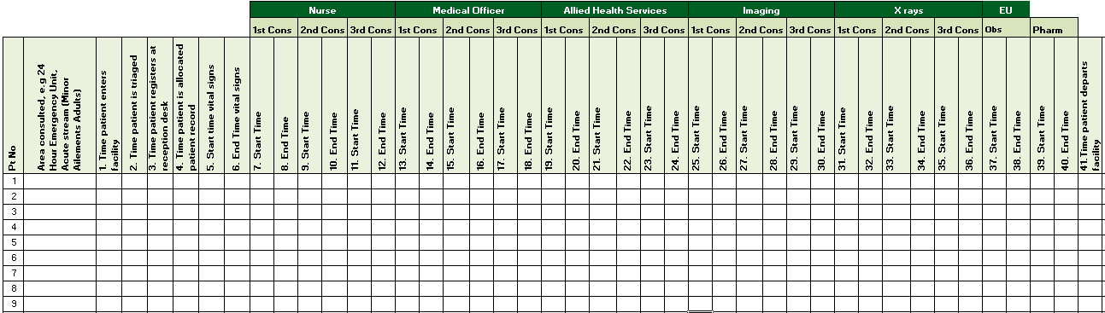
- Waiting time registration: No 3 minus 1
- Waiting time triage: No 2 minus 1
- Waiting time patient record: No 4 minus 3
- Waiting time vital signs: No 5 minus 4
- Waiting time 3 streams of care No 7 minus 6
- Waiting time medical officer: No 13 minus last consultation before visiting medical doctor/vital signs
Abbreviations:
Cons: Consultations
Eu: Emergency Unit
Obs: Observation
Pt: Patient
Pharm: Pharmacy
- Waiting time Allied Health Services No 19 minus last consultation before visiting Allied Health Services
- Waiting time imaging: No 25 minus last consultation before visiting imaging
- Waiting time X rays: No 31 minus last consultation before visiting x-rays
- Waiting time observation in EU No 37 minus last consultation before going for observation
- Waiting time Pharmacy: No 39 minus last consultation before visiting pharmacy
Total patient waiting time: sum of (a) to (k)

Note: if patients return for a 2nd and/or 3rd consultation at the same type of health care provider, the PWT for those consultations must be added to the total PWT
Appendix D: Patient Waiting Time Monitoring Tool for hospitals: Admissions Unit

Record the patient number (e.g. 1 to 100):
Name of facility:

Date of Survey:

Area | Time
Time patient enters unit¹ | Hours |  | Minutes
Time patient registers at admission/reception desk | Hours |  | Minutes
Area | Start Time |  | End Time
Time patient completes vital signs | Hours | Minutes | Hours | Minutes
Area | Time
Time patient allocated a designated bed in the ward² | Hours |  | Minutes

¹ When the patient enters the door of the Admissions unit, the queue marshal (or designated staff member) should record the time
² All administrative processes completed and patients allocated a designated bed in the ward

Appendix E: Patient Waiting Time Monitoring Tool for hospitals: Emergency Unit

Record the patient number (e.g. 1 to 100):
Name of facility:

Date of Survey:

Area | Time
Time patient enters unit¹ | Hours |  | Minutes
Time patient is triaged | Hours |  | Minutes
Time patient registers at reception desk | Hours |  | Minutes
Area Type of health  care provider | Start time |  | End time
Vital signs | Hours | Minutes | Hours | Minutes
Medical officer
1st consultation | Hours | Minutes | Hours | Minutes
2nd consultation² | Hours | Minutes | Hours | Minutes
3rd consultation² | Hours | Minutes | Hours | Minutes
Medical specialist
1st consultation² | Hours | Minutes | Hours | Minutes
2nd consultation² | Hours | Minutes | Hours | Minutes
3rd consultation² | Hours | Minutes | Hours | Minutes
X-rays
1st consultation² | Hours | Minutes | Hours | Minutes
2nd consultation² | Hours | Minutes | Hours | Minutes
2nd consultation² | Hours | Minutes | Hours | Minutes
Imaging (ultrasound and scans)
1st consultation² | Hours | Minutes | Hours | Minutes
2nd consultation² | Hours | Minutes | Hours | Minutes
3rd consultation² | Hours | Minutes | Hours | Minutes
Pharmacy | Hours | Minutes | Hours | Minutes
Observation (12 to 24 hour observation)³ | Hours | Minutes | Hours | Minutes
Time patient departs unit⁴ |  |  | Hours | Minutes

¹ When the patient enters the door of the unit, the queue marshal (or designated staff member) should record the time
² Applicable if referred
³ Applicable if kept for observation
⁴ The last point of contact with service provision

Appendix F: Patient Waiting Time Monitoring Tool for hospitals: OPD
Name of facility:
Record the patient number (e.g. 1 to 100):

Name of OPD:

Date of Survey:
Area | Time
Time patient enters unit¹ | Hours |  | Minutes
Time patient registers at reception desk | Hours |  | Minutes
Area Type of health  care provider | Start time |  | End time
Vital signs | Hours | Minutes | Hours | Minutes
Medical officer
1st consultation | Hours | Minutes | Hours | Minutes
2nd consultation² | Hours | Minutes | Hours | Minutes
3rd consultation² | Hours | Minutes | Hours | Minutes
Medical specialist
1st consultation² | Hours | Minutes | Hours | Minutes
2nd consultation² | Hours | Minutes | Hours | Minutes
3rd consultation² | Hours | Minutes | Hours | Minutes
X-rays
1st consultation² | Hours | Minutes | Hours | Minutes
2nd consultation² | Hours | Minutes | Hours | Minutes
2nd consultation² | Hours | Minutes | Hours | Minutes
Imaging (ultrasound and scans)
1st consultation² | Hours | Minutes | Hours | Minutes
2nd consultation² | Hours | Minutes | Hours | Minutes
3rd consultation² | Hours | Minutes | Hours | Minutes
Laboratory
1st consultation² | Hours | Minutes | Hours | Minutes
2nd consultation² | Hours | Minutes | Hours | Minutes
3rd consultation² | Hours | Minutes | Hours | Minutes
Support Services (allied health services including Oral health, social worker, nutritionist etc.)
1st consultation² | Hours | Minutes | Hours | Minutes
2nd consultation² | Hours | Minutes | Hours | Minutes
3rd consultation² | Hours | Minutes | Hours | Minutes
Pharmacy | Hours | Minutes | Hours | Minutes
Time patient departs unit³ |  |  | Hours | Minutes
¹ When the patient enters the door of the unit, the queue marshal (or designated staff member) should record the time
² Applicable if referred
³ The pharmacy is usually the exit touch point after patient has made their return appointment at the designated reception or administrative point.

Appendix G: Patient Waiting Time Calculation Tool: Hospitals
Name of Facility: _____________________
Number of patients
surveyed
9
Date: _____________________
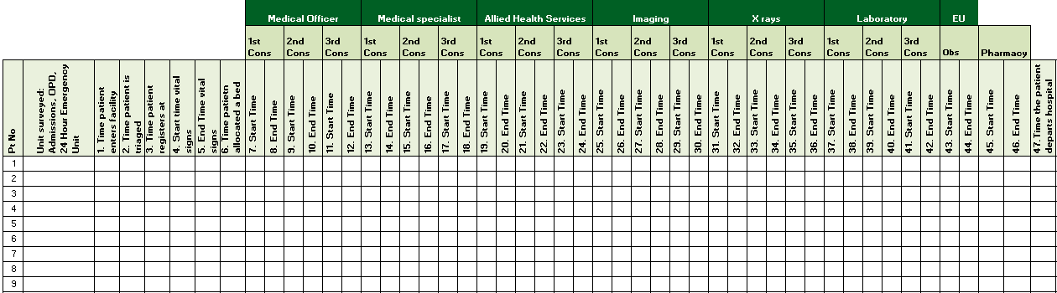
- Waiting time registration: No 3 minus 1
- Waiting time triage: No 2 minus 1
- Waiting time vital signs: No 4 minus 3
- Waiting time allocated to bed (Adms) No 6 minus 5
Abbreviations:
Adms: Admissions
Cons: Consultations
Eu: Emergency Unit
Obs: Observation
Pt: Patient
Pharm: Pharmacy
- Waiting time medical officer: No 13 minus last consultation before visiting medical doctor/vital signs
- Waiting time Allied Health Services No 19 minus last consultation before visiting imaging
- Waiting time imaging: No 25 minus last consultation before visiting imaging
- Waiting time X rays: No 31 minus last consultation before visiting x-rays
- Waiting time Laboratory: No 37 minus last consultation before visiting laboratory
- Waiting time observation in EU No 43 minus last consultation before going for observation
- Waiting time Pharmacy: No 45 minus last consultation before visiting pharmacy
Total waiting time: sum of (a) to (j)

Note: if patients return for a 2nd and/or 3rd consultation at the same type of health care provider, the PWT for those consultations must be added to the total PWT

